COMPUTER GRAPHICS
MINI PROJECT

Group Members:
18CO05 – Khan Zarin Begum Mohammed Shafi
18CO08 - Nair Shruti Unnikrishan
18CO19 – Sakib Mukhtar Arkate
Topic :
BOUNCING BALL USING OPENGL

OBJECTIVE :
To implement various opengl functions to get output of
Bouncing Ball.

INPUT:
In this program we don't have to provide any input because when we run the program, a window appears with a Bouncing Ball.
OUTPUT:
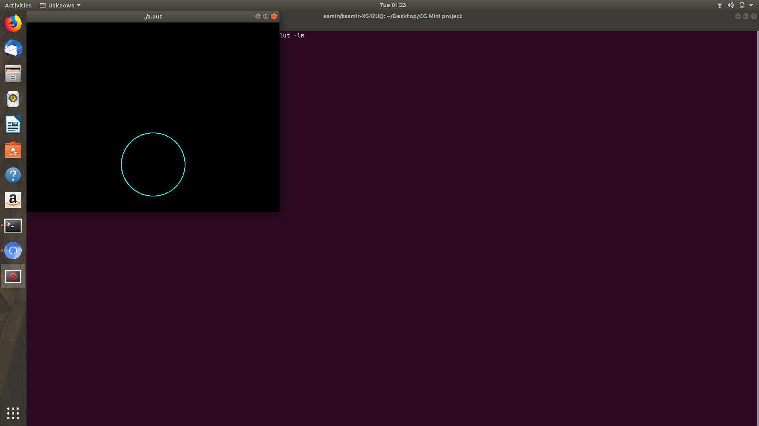
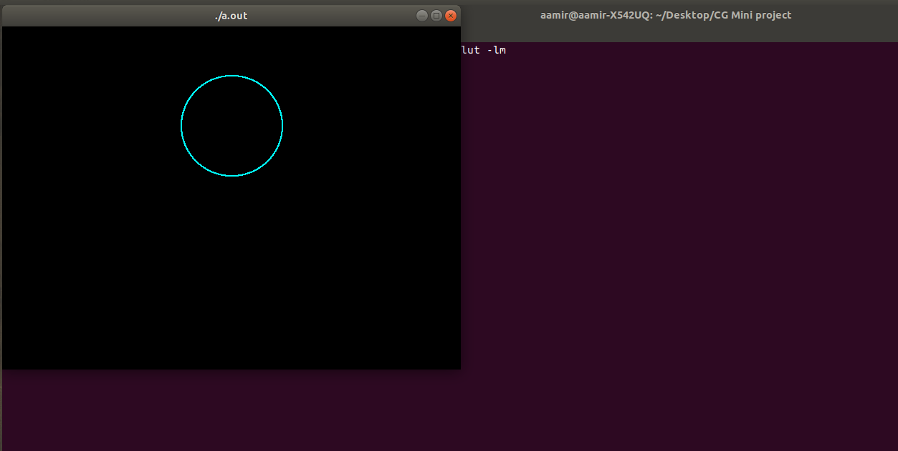

REFERENCE:
1- www.opengl.org
2- www.youtube.com
3- www.opengltutorial.com

CONCLUSION:
In this mini project we have implemented a moving boat program in OpenGL using various OpenGL functions. We have understood the concept of OpenGL and the various functions of OpenGL.

CODE:
#include <GL/glut.h>
#include <GL/gl.h>
#include <GL/glu.h>
#include <math.h>
#include <stdio.h>
#include <string.h>
#define WIDTH 640
#define HEIGHT 480
void reshape(int width, int height)
{
glViewport(0,0,width,height);
glMatrixMode(GL_PROJECTION);
glLoadIdentity();
glOrtho(-WIDTH/2,WIDTH/2-1,-HEIGHT/2,HEIGHT/2-1,-1,1);
glMatrixMode(GL_MODELVIEW);
glLoadIdentity();
}
void init(void)
{
glClearColor(0.0,0.0,0.0,1.0);
glPointSize(2.0);
}
void Timer(int ex)
{
glutPostRedisplay();
glutTimerFunc(30,Timer,0);
}
int k=20;
void circle(int p,int m)
{
int x=0,y,d,r;
r=m;
y=r;
d=3-2*r;
while(x<=y)
{
glVertex2i(x,y+p);
glVertex2i(y,x+p);
glVertex2i(-x,y+p);
glVertex2i(-y,x+p);
glVertex2i(-x,-y+p);
glVertex2i(-y,-x+p);
glVertex2i(y,-x+p);
glVertex2i(x,-y+p);
if(d<0)
d=d+4*x+6;
else
{
d=d+4*(x-y)+10;
y--;
}
x++;
}
}
int r=100,flag=0;
void display(void)
{

glClear(GL_COLOR_BUFFER_BIT | GL_DEPTH_BUFFER_BIT);
glColor4f(0.0,1.0,1.0,1.0);
glBegin(GL_POINTS);
circle(k,r);
if(flag==0)
{
if((k+r)<=240)
{
k=k+10;
}
if((k+r)>=240){
flag=1;
}
}
if(flag==1)
{
k=k-10;
if((k-r)<=-240)
{
flag=0;
if(r!=10)
r=r-10;
}
}
glEnd();
glutSwapBuffers();
}
void idle(void){
}
int main(int argc, char **argv){
glutInit(&argc,argv);
glutInitDisplayMode(GLUT_DOUBLE | GLUT_RGBA | GLUT_DEPTH);
glutInitWindowPosition(0,0);
glutInitWindowSize(WIDTH,HEIGHT);
glutCreateWindow(argv[0]);
init();
glutIdleFunc(idle);
glutReshapeFunc(reshape);
glutDisplayFunc(display);
glutTimerFunc(0,Timer,0);
glutMainLoop();
return(1);
}

